**ABOUT MICROPROCESSORS**

**Introduction to Microprocessor**

* **CPU** built on top of a **single IC**.
* Basically, a **semi-CPU**.
* Computer with one **microprocessor** is called ***microcomputer***.
* When we have **multiple microprocessors** then they collectively provide high computation power to a system.
* These **microprocessors** parallelly work on various computations & send collective output.

**Features of Microprocessor**

* Programmable
* Multi-purpose
* Clock-driven
* Register-based
* Reads & writes binary instructions.

**Microcomputer Block Diagram**

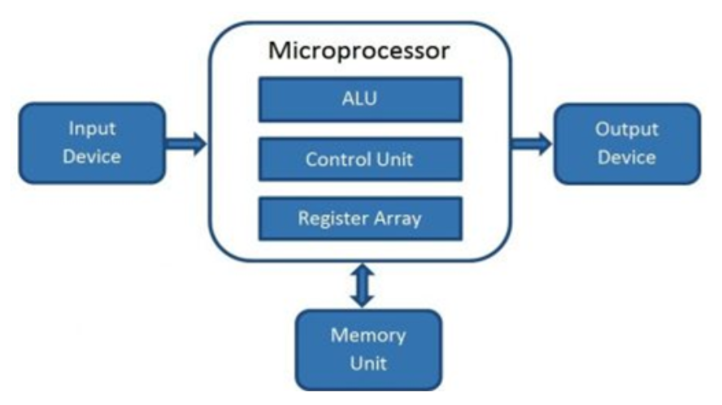

* **Control unit (CU):** Controls instructions & flow of data.
* **Register array:** Contains register **B**, **C**, **D**, **E**, **F**, **G**, **H**, **L** & **A**.

**Evolution of Microprocessors**

* 1st Generation (**4-bit** microprocessors)
* 2nd Generation (**8-bit** microprocessors)
* …
* 5th Generation (**64-bit** microprocessors)

**8085 Specifications**

|  |  |
| --- | --- |
| **Word length** | **8-bit** |
| **Memory addressing capacity** | **64 KB** |
| **Pins** | **40** |
| **Clock** | **3-6 MHz** |

**Basic Extensions Used**

* **PGA –** Pin grid array
* **MMX –** Multi-media extensions
* **EPIC –** Explicitly parallel instruction computing
* **SIMD –** Single instruction multi-data
* **FPU –** Floating point unit

**Basic Terminologies**

* **Instruction set:** Programming set that the microprocessor uses.
* **Bus:** Conductors used for **communicating** with various microprocessor components via **electric transmission**.
* **Types of buses –** Data bus, address bus & control bus.
* **Instruction per cycle (IPC):** Number of instructions a microprocessor can execute per clock cycle.
* **Clock speed:** Number of operations that can be performed per second. Measured in **Hertz**.
* **Bandwidth:** Number of **bits** **processed** per second.
* **Word length:** Number of bits that can be **processed** per second.
* **Data types –** Binary, ASCII, signed, unsigned etc.

**Working of Microprocessor**

* It ***fetches***, ***decodes*** & then ***executes***.
* **Step 1:** It **fetches** instructions from storage memory.
* **Step 2:** **Decodes** the information.
* **Step 3:** **Executes** those instructions until STOP instruction is met.
* **Step 4:** Result is **sent** to output port in binary.

**Advantages of Microprocessors**

* **Low cost –** Integrated technology uses less materials.
* **High speed**
* **Small size**
* **Versatile –** Variety of applications.
* **Low power consumption –** As it uses MOS.
* **Less heat generation –** Semiconductors release less heat.
* **Reliable –** Failure rate is less to no in semiconductors.